Ideation Phase
Define the Problem Statements

Date | 02 October 2026
Team ID | SWTID-2026-2230
Project Name | Streamlining IT Procurement: Automating Standard Laptop Orders with Flow Designer
Maximum Marks | 2 Marks

Customer Problem Statement Template:
Create a problem statement to understand your customer's point of view. The Customer Problem Statement template helps you focus on what matters to create experiences people
A well-articulated customer problem statement allows you and your team to find the ideal solution for the challenges your customers face. Throughout the process, you’ll also be able to empathize with your customers, which helps you better understand how they perceive your product or service.
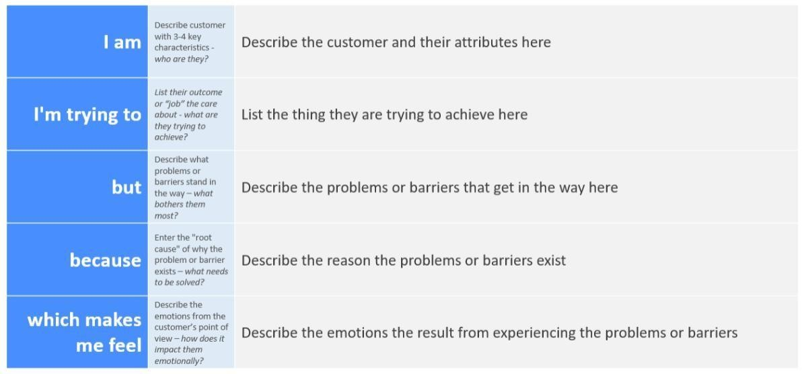
Reference: https://miro.com/templates/customer-problem-statement/ Example:


Customer Problem Statement
Which
Problem Statement | I am (Customer) | I’m trying to | But | Because | makes me feel
PS-1 | An Employee | Request a standard laptop for my work | The request process is slow and involves multiple manual steps | Laptop requests, approvals, and procurement activities are handled separately | Frustrated and  uncertain  about my  request status
PS-2 | A Manager | Review and approve laptop requests quickly | I have to manually  check request details and communicate  with the  employee | There is no automated approval workflow | Delayed and overloaded with repetitive tasks
PS-3 | An IT  Administrator | Process laptop requests efficiently | I need to manually validate requests, check  availability,  and create procurement tasks | The procurement  process is not fully  automated | Stressed and concerned about errors
PS-4 | A  Procurement  Team  Member | Process approved laptop orders on time | I may receive incomplete or delayed request information | Request and approval information is not automatically transferred to procurement | Delayed and  inefficient
PS-5 | An Employee | Track the progress  of my  laptop order | I do not always receive timely status updates | Order tracking and notifications  are handled manually | Anxious and unsure about when I will receive the laptop

